**DAILY ONLINE ACTIVITIES SUMMARY**

|  |  |  |  |  |  |  |  |  |
| --- | --- | --- | --- | --- | --- | --- | --- | --- |
| **Date:** | **10/06/2020** | | | | | **Name:** | **Archana J C** | |
| **Sem & Sec** | **4th**  **‘A’** | | | | | **USN:** | **4AL18CS011** | |
| **Online Test Summary** | | | | | | | | |
| **Subject** | | **Object oriented concepts** | | | | | | |
| **Max. Marks** | | **30** | | **Score** | | | **14** | |
| **Certification Course Summary** | | | | | | | | |
| **Course** | **Data Visualization using Python** | | | | | | | |
| **Certificate Provider** | | | **Great learning academy** | | **Duration** | | | **2hours** |
| **Coding Challenges** | | | | | | | | |
| Java Program to find the longest repeating sequence in a string | | | | | | | | |
| **Status: Completed** | | | | | | | | |
| **Uploaded the report in Github** | | | | | **Yes** | | | |
| **If yes Repository name** | | | | | **https://github.com/alvas-education-foundation/archana_j_c** | | | |
| **Uploaded the report in slack** | | | | | **Yes** | | | |

Online Test Details: (Attach the snapshot and briefly write the report for the same)

The online test was from module 3 and 4. There were 15 questions and the duration was 30 minutes. The questions were optimal. The score that I got in the test is 14/30.

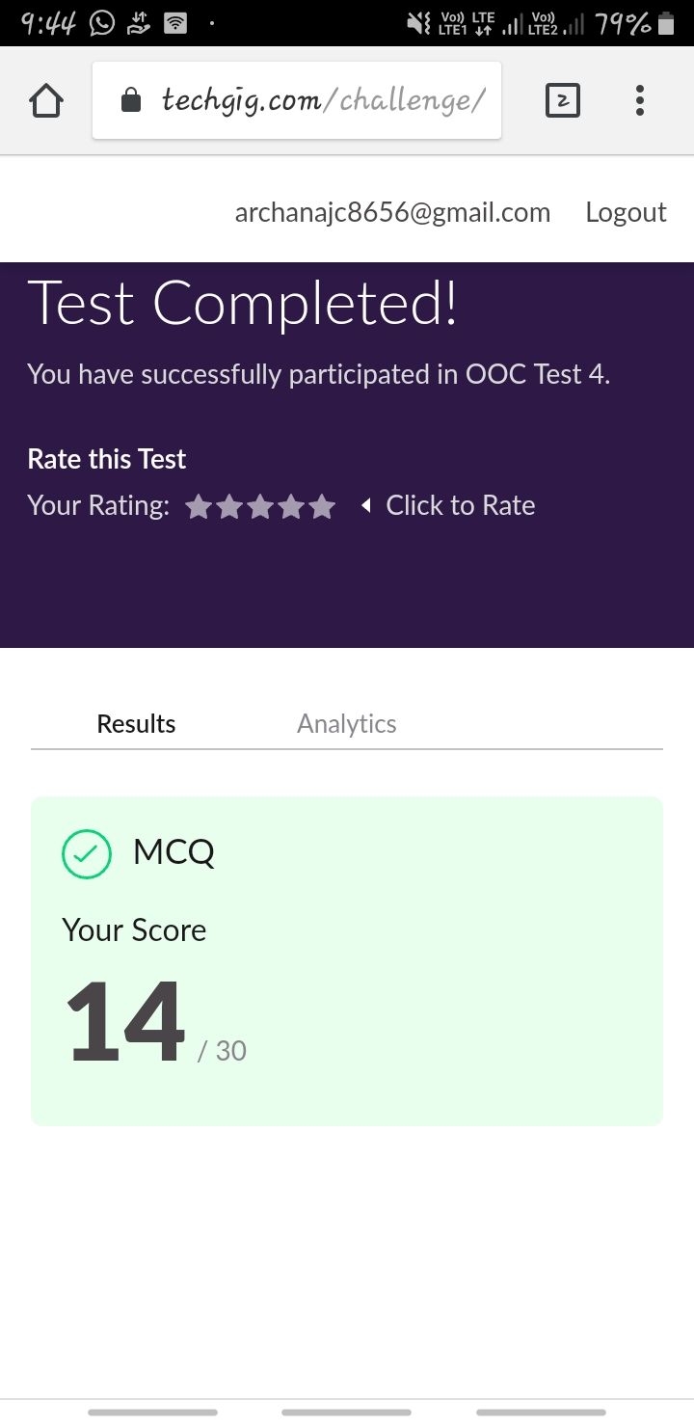

Certification Course Details: (Attach the snapshot and briefly write the report for the same)

#### COURSE NAME : Data Visualization using Python

CERTIFICATION PROVIDERS : Great learning academy

The course is about data visualization, which includes Introduction to Visualization, Matplotlib, Seaborn and Plotly, Visualization Techniques and Comparing Different plots on Automobile Dataset, Numpy, Pandas (Kaggle Automobile Dataset)

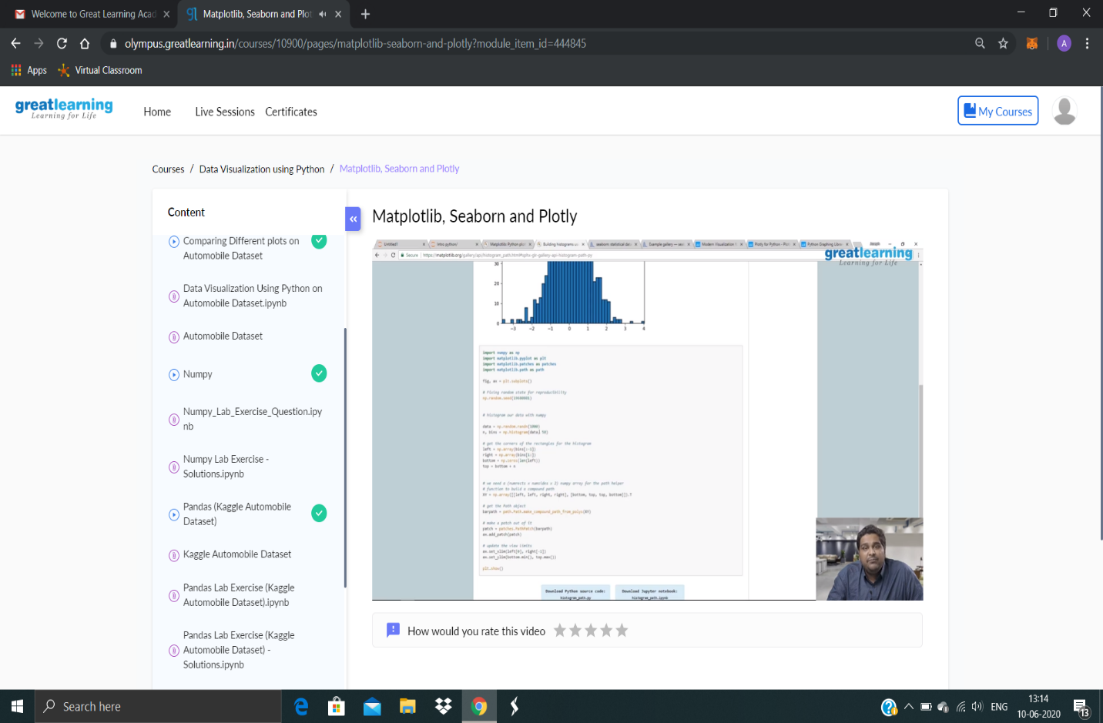

Coding Challenges Details: (Attach the snapshot and briefly write the report for the same)

Today I’m done with some java program. The solution are already uploaded in github repository

**Program1 :** Java Program to find the longest repeating sequence in a string

